## Oppg1

1. Bruker numeric division.

Er også vist I koden nederst I dokumentet.

1. Bruker numerisk integrasjon. Med algoritmen

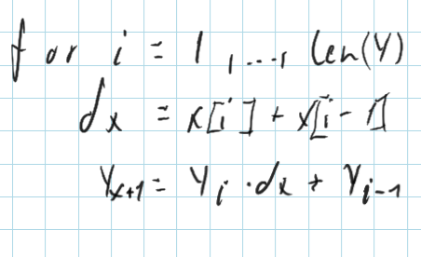

Der Y[i] er integrasjonen fra 0 til i av Y. også vist i koden.

1. Framgangsmåte i koden.

Integralet viser lengden, derivate viser akselerasjonen, og V viser farten.

Framgangsmåte ligger i koden.

C) I python koden

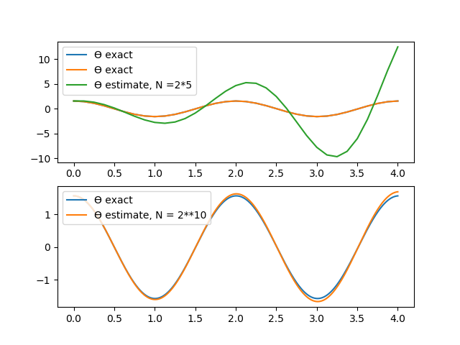

Ser at estimatet blir mer nøyaktig når vi øker N, og at ved liten N så blir estimatetr mer og mer usikkert jo lengere fra x=0 vi kommer.

1. Estimatet er

---------------

N = 16

err[1] = 0.00011756377981275712

err[103] = 0.0038099404835139072

err[205] = 0.019454896734367066

err[307] = 0.030003221985847484

err[409] = 0.013649685114557941

err[511] = 0.0611889219864572

err[613] = 0.026145718107934424

err[715] = 0.06684992331497353

err[817] = 0.08377880498442503

err[919] = 0.026552753305578047

err[1021] = 0.12430267382042826

---------------

N = 32

err[1] = 0.00011756377981275712

err[103] = 0.0038099404835139072

err[205] = 0.019454896734367066

err[307] = 0.030003221985847484

err[409] = 0.013649685114557941

err[511] = 0.0611889219864572

err[613] = 0.026145718107934424

err[715] = 0.06684992331497353

err[817] = 0.08377880498442503

err[919] = 0.026552753305578047

err[1021] = 0.12430267382042826

---------------

N = 64

err[1] = 0.00011756377981275712

err[103] = 0.0038099404835139072

err[205] = 0.019454896734367066

err[307] = 0.030003221985847484

err[409] = 0.013649685114557941

err[511] = 0.0611889219864572

err[613] = 0.026145718107934424

err[715] = 0.06684992331497353

err[817] = 0.08377880498442503

err[919] = 0.026552753305578047

err[1021] = 0.12430267382042826

---------------

N = 128

err[1] = 0.00011756377981275712

err[103] = 0.0038099404835139072

err[205] = 0.019454896734367066

err[307] = 0.030003221985847484

err[409] = 0.013649685114557941

err[511] = 0.0611889219864572

err[613] = 0.026145718107934424

err[715] = 0.06684992331497353

err[817] = 0.08377880498442503

err[919] = 0.026552753305578047

err[1021] = 0.12430267382042826

---------------

N = 256

err[1] = 0.00011756377981275712

err[103] = 0.0038099404835139072

err[205] = 0.019454896734367066

err[307] = 0.030003221985847484

err[409] = 0.013649685114557941

err[511] = 0.0611889219864572

err[613] = 0.026145718107934424

err[715] = 0.06684992331497353

err[817] = 0.08377880498442503

err[919] = 0.026552753305578047

err[1021] = 0.12430267382042826

---------------

N = 512

err[1] = 0.00011756377981275712

err[103] = 0.0038099404835139072

err[205] = 0.019454896734367066

err[307] = 0.030003221985847484

err[409] = 0.013649685114557941

err[511] = 0.0611889219864572

err[613] = 0.026145718107934424

err[715] = 0.06684992331497353

err[817] = 0.08377880498442503

err[919] = 0.026552753305578047

err[1021] = 0.12430267382042826

---------------

N = 1024

err[1] = 0.00011756377981275712

err[103] = 0.0038099404835139072

err[205] = 0.019454896734367066

err[307] = 0.030003221985847484

err[409] = 0.013649685114557941

err[511] = 0.0611889219864572

err[613] = 0.026145718107934424

err[715] = 0.06684992331497353

err[817] = 0.08377880498442503

err[919] = 0.026552753305578047

err[1021] = 0.12430267382042826

1. Er i koden
2. Er i koden

# Koden

import numpy as np

import matplotlib.pyplot as plt

#c)

def lin_pendel_euler(v0, theta0, g, L, N, T, h=None):

if h is None:

h = T/N

v, theta = [0]*(N+1), [0]*(N+1)

v[0], theta[0] = v0, theta0

for k in range(N):

v[k+1] = v[k] - g*h*theta[k]

theta[k+1] = theta[k] + h*(v[k]/L)

return v, theta

#d)

def lin_pendel(t, v0, theta0, g, L):

return theta0 * np.cos(np.sqrt(g/L)*t) + v0 * np.sin(np.sqrt(g/L)*t)

g, L, v0, theta0, T, N1 = 9.81, 1, 0, np.pi/2, 4, 2**5

v_hat, theta_hat = lin_pendel_euler(v0, theta0, g, L, N1, T)

t1 = np.linspace(0,T,N1+1) #[h*k for k in range(N)]

theta1 = lin_pendel(t1, v0, theta0, g, L)

plt.subplot(2, 1, 1)

plt.plot(t1,theta1, label='ϴ exact')

plt.plot(t1,theta_hat, label='ϴ estimate, N =2*5')

plt.legend()

plt.subplot(2, 1, 2)

N2 = 2**10

v_hat, theta_hat = lin_pendel_euler(v0, theta0, g, L, N2, T)

t2 = np.linspace(0,T,N2+1) #[h*k for k in range(N)]

theta2 = lin_pendel(t2, v0, theta0, g, L)

plt.plot(t2,theta2, label='ϴ exact')

plt.plot(t2,theta_hat, label='ϴ estimate, N = 2**10')

plt.legend()

plt.show()

#e)

def epsilon(N, h=None):

t = np.linspace(0,T,N+1)

theta = lin_pendel(t, v0, theta0, g, L)

theta_hat = np.asarray(lin_pendel_euler(v0, theta0, g, L, N, T, h)[-1])

err = np.absolute(theta-theta_hat)

return err

n = [2**i for i in range(4,10+1)]

for N in n:

err = epsilon(2**10)

print('''---------------

N = {}'''.format(N))

for i in range(1, len(err), int(len(err)/10)):

print('err[{}] = {}'.format(i, err[i]))

#f)

def p(epsilon):

N = 2**4

h2 = (T/N)/2

h1 = T/N

return (np.log(epsilon(N)/epsilon(N)))/np.log(h1/h2)

print(p(epsilon))

#g

def pendel_euler(v0, theta0, g, L, N, h):

v = theta =np.zeros(N+1)

v[0], theta[0] = v0, theta0

for k in range(N):

v[k+1] = v[k] - g*h*np.sin(theta[k])

theta[k+1] = theta[k] + h * v[k]/L

return v, theta

h1 = T/N1

h2 = T/N2

v_pen1, theta_pen1 = pendel_euler(v0, theta0, g, L, N1, h1)

v_pen2, theta_pen2 = pendel_euler(v0, theta0, g, L, N2, h2)

plt.subplot(2, 1, 1)

plt.plot(t1,theta1, label='ϴ exact')

plt.plot(t1,theta_hat, label='ϴ estimate, N =2*5')

plt.plot(t1,theta_pen1, label = 'ϴ theta_pen, N = 2*5')

plt.legend()

plt.subplot(2, 1, 2)

N2 = 2**10

v_hat2, theta_hat2 = lin_pendel_euler(v0, theta0, g, L, N2, T)

theta = lin_pendel(t2, v0, theta0, g, L)

plt.plot(t2,theta2, label='ϴ exact')

plt.plot(t2,theta_hat2, label='ϴ estimate, N = 2**10')

plt.plot(t2,theta_pen2, label = 'ϴ theta_pen, N = 2*10')

plt.legend()

plt.show()

## Kjøreeksempel

---------------

N = 16

err[1] = 0.00011756377981275712

err[103] = 0.0038099404835139072

err[205] = 0.019454896734367066

err[307] = 0.030003221985847484

err[409] = 0.013649685114557941

err[511] = 0.0611889219864572

err[613] = 0.026145718107934424

err[715] = 0.06684992331497353

err[817] = 0.08377880498442503

err[919] = 0.026552753305578047

err[1021] = 0.12430267382042826

---------------

N = 32

err[1] = 0.00011756377981275712

err[103] = 0.0038099404835139072

err[205] = 0.019454896734367066

err[307] = 0.030003221985847484

err[409] = 0.013649685114557941

err[511] = 0.0611889219864572

err[613] = 0.026145718107934424

err[715] = 0.06684992331497353

err[817] = 0.08377880498442503

err[919] = 0.026552753305578047

err[1021] = 0.12430267382042826

---------------

N = 64

err[1] = 0.00011756377981275712

err[103] = 0.0038099404835139072

err[205] = 0.019454896734367066

err[307] = 0.030003221985847484

err[409] = 0.013649685114557941

err[511] = 0.0611889219864572

err[613] = 0.026145718107934424

err[715] = 0.06684992331497353

err[817] = 0.08377880498442503

err[919] = 0.026552753305578047

err[1021] = 0.12430267382042826

---------------

N = 128

err[1] = 0.00011756377981275712

err[103] = 0.0038099404835139072

err[205] = 0.019454896734367066

err[307] = 0.030003221985847484

err[409] = 0.013649685114557941

err[511] = 0.0611889219864572

err[613] = 0.026145718107934424

err[715] = 0.06684992331497353

err[817] = 0.08377880498442503

err[919] = 0.026552753305578047

err[1021] = 0.12430267382042826

---------------

N = 256

err[1] = 0.00011756377981275712

err[103] = 0.0038099404835139072

err[205] = 0.019454896734367066

err[307] = 0.030003221985847484

err[409] = 0.013649685114557941

err[511] = 0.0611889219864572

err[613] = 0.026145718107934424

err[715] = 0.06684992331497353

err[817] = 0.08377880498442503

err[919] = 0.026552753305578047

err[1021] = 0.12430267382042826

---------------

N = 512

err[1] = 0.00011756377981275712

err[103] = 0.0038099404835139072

err[205] = 0.019454896734367066

err[307] = 0.030003221985847484

err[409] = 0.013649685114557941

err[511] = 0.0611889219864572

err[613] = 0.026145718107934424

err[715] = 0.06684992331497353

err[817] = 0.08377880498442503

err[919] = 0.026552753305578047

err[1021] = 0.12430267382042826

---------------

N = 1024

err[1] = 0.00011756377981275712

err[103] = 0.0038099404835139072

err[205] = 0.019454896734367066

err[307] = 0.030003221985847484

err[409] = 0.013649685114557941

err[511] = 0.0611889219864572

err[613] = 0.026145718107934424

err[715] = 0.06684992331497353

err[817] = 0.08377880498442503

err[919] = 0.026552753305578047

err[1021] = 0.12430267382042826

[nan 0. 0. 0. 0. 0. 0. 0. 0. 0. 0. 0. 0. 0. 0. 0. 0.]

D:\OneDrive - Universitetet i Oslo\UIO\MAT-INF1100\Oblig2\oppg2.py:71: RuntimeWarning: invalid value encountered in true_divide

return (np.log(epsilon(N)/epsilon(N)))/np.log(h1/h2)

Traceback (most recent call last):

File "D:\OneDrive - Universitetet i Oslo\UIO\MAT-INF1100\Oblig2\oppg2.py", line 93, in <module>

plt.plot(t1,theta_hat, label='\u03f4 estimate, N =2*5')

File "C:\Users\SKJSA\AppData\Local\Programs\Python\Python37\lib\site-packages\matplotlib\pyplot.py", line 2749, in plot

*args, scalex=scalex, scaley=scaley, data=data, **kwargs)

File "C:\Users\SKJSA\AppData\Local\Programs\Python\Python37\lib\site-packages\matplotlib\__init__.py", line 1785, in inner

return func(ax, *args, **kwargs)

File "C:\Users\SKJSA\AppData\Local\Programs\Python\Python37\lib\site-packages\matplotlib\axes\_axes.py", line 1604, in plot

for line in self._get_lines(*args, **kwargs):

File "C:\Users\SKJSA\AppData\Local\Programs\Python\Python37\lib\site-packages\matplotlib\axes\_base.py", line 393, in _grab_next_args

yield from self._plot_args(this, kwargs)

File "C:\Users\SKJSA\AppData\Local\Programs\Python\Python37\lib\site-packages\matplotlib\axes\_base.py", line 370, in _plot_args

x, y = self._xy_from_xy(x, y)

File "C:\Users\SKJSA\AppData\Local\Programs\Python\Python37\lib\site-packages\matplotlib\axes\_base.py", line 231, in _xy_from_xy

"have shapes {} and {}".format(x.shape, y.shape))

ValueError: x and y must have same first dimension, but have shapes (33,) and (1025,)

[Finished in 2.176s]